Fig. 1. Sampling Location Map, Reconnesance Visit to ITOK GmbH Gold Resources at Dinguiraye, Guinea, May 2009
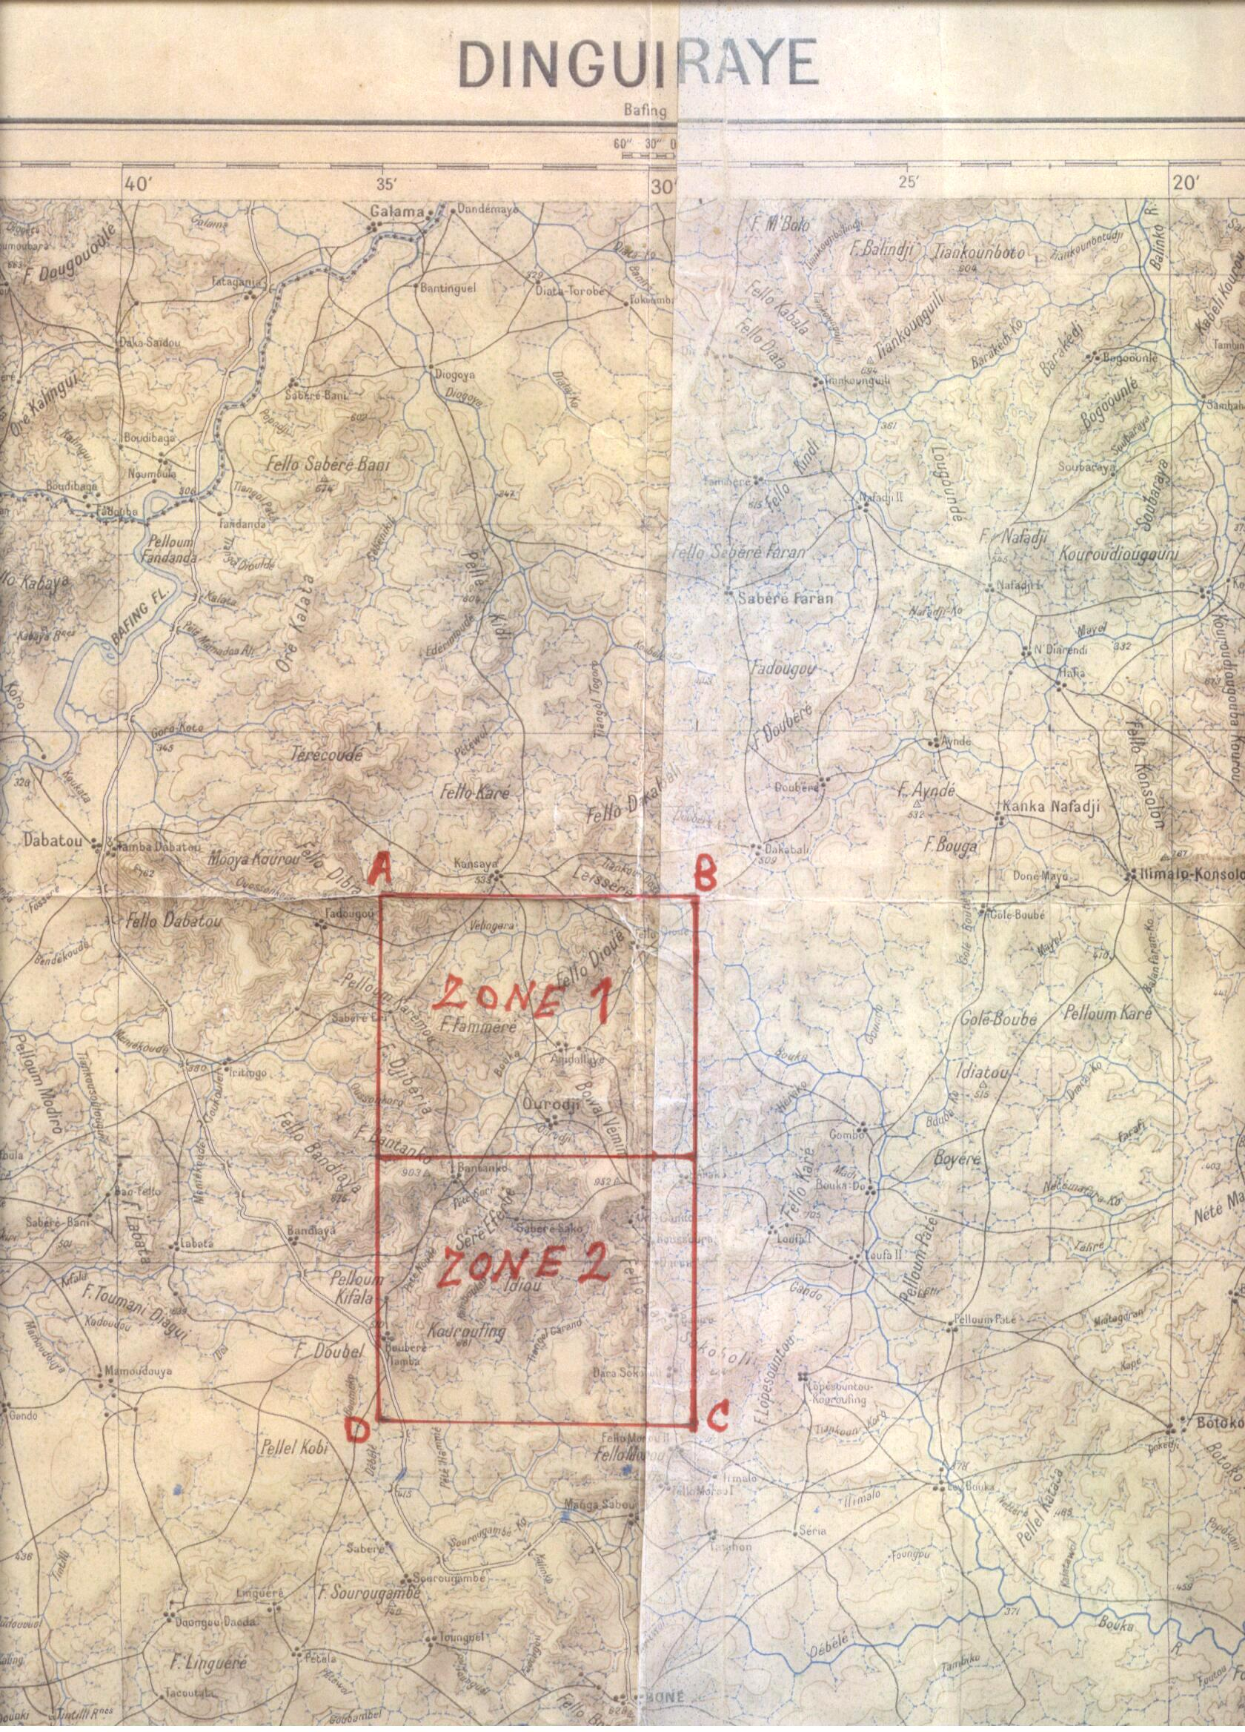
Sampling at Kouroufing
Sampling at Rogaya

